

CLASS : XITH SUBJECT : PHYSICS
DATE : DPP NO. : 4
Topic :- SYSTEM OF PARTICLES AND ROTATIONAL MOTION
1. Moment of inertia of a sphere of mass $M$ and radius $R$ is $I$. Keeping $M$ constant if a graph is plotted between $I$ and $R$, then its form would be
a) b)
I
R
I
R
c) d)
I
R
I
R

2. Four bodies of equal mass start moving with same speed are shown in the figure. In which of the following combination the centre of mass will remain at origin?
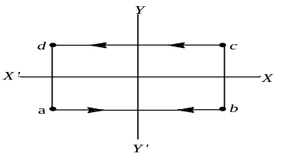
a) $cd$b) $ab$c) $ac$ d) $bd$

3. A solid sphere of radius $R$ has moment of inertia $I$ about its geometrical axis. If it is melted into a disc of radius $r$ and thickness $t$. If its moment of inertia about the tangential axis (which is perpendicular to plane of the disc), is also equal to $I$, then the value of $r$ is equal to
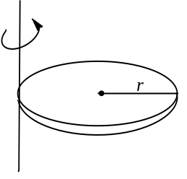
a) $\frac{2}{\sqrt{15}} R$ b) $\frac{2}{\sqrt{5}} R$ c) $\frac{3}{\sqrt{15}} R$ d) $\frac{\sqrt{3}}{\sqrt{15}} R$

4. One circular ring and one circular disc, both are having the same mass and radius. The ratio of their moments of inertia about the axes passing through their centres and perpendicular to their planes, will be
a) 1 :1 b) 2 :1 c) 1 :2 d) 4 :1

5. Moment of inertia of ring of mass $M$ and radius $R$about an axis passing through the centre and perpendicular to the plane is $I$. What is the moment of inertia about its diameter?
a) $I$ b) $\frac{I}{2}$ c) $\frac{I}{\sqrt{2}}$ d) ${I+MR}^{2}$

6. A uniform cylinder has a radius $R$ and length $L$. If the moment of inertia of this cylinder about an axis passing through its centre and normal to its circular face is equal to the moment of inertia of the same cylinder about an axis passing through its centre and perpendicular to its length, then
a) $L=R$ b) $L=\sqrt{3}R$ c) $L=\frac{R}{\sqrt{3}}$ d) $L=\sqrt{\frac{3}{2}}R$

7. A ball falls freely from a height of 45m. When the ball is at a height of 25 m, it explodes into two equal pieces. One of them moves horizontally with a speed of 10 $ms^{-1}$. The distance between the two pieces when both strike the ground is
a) 10 m b) 20 m c) 15 m d) 30 m

8. A body comes running and sits on a rotating platform. What is conserved
a) Linear momentum b) Kinetic energy
c) Angular momentum d) None of the above

9. According to the theorem of parallel axes $I=I_{cm}+Mx^{2},$ the graph between $I$ and $x$ will be
a) b) c) d)
I
x
O
I
x
O
I
x
O
I
x
O

10. A uniform rod $AB$ of length $l$ and mass $m$ is free to rotate about point $A$. The rod is released from rest in horizontal position. Given that the moment of inertia of the rod about $A$ is $\frac{ml^{2}}{3}$ the initial angular acceleration of the rod will be
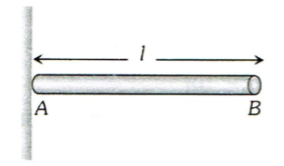
a) $\frac{2g}{3l}$ b) $mg\frac{l}{2}$ c) $\frac{3}{2}gl$ d) $\frac{3g}{2l}$
11. A small disc of radius 2 cm is cut from a disc of radius 6 cm. If the distance between their centres is 3.2 cm, what is the shift in the centre of mass of the disc?
a) 0.4 cm b) 2.4 cm c) 1.8 cm d) 1.2 cm

12. Two spheres of masses $2M$ and $M$ are initially at rest at a distance $R$ apart. Due to mutual force of attraction, they approach each other. When they are at separation $R/2$, the acceleration of the centre of mass of spheres would be
a) $0 m/s^{2}$ b) $g m/s^{2}$ c) $3g m/s^{2}$ d) $12g m/s^{2}$

13. A ring of radius $0.5 m$ and mass $10 kg$ is rotating about its diameter with angular velocity of $20 rad/s$. Its kinetic energy is
a) $10 J$ b) $100 J$ c) $500 J$ d) $250 J$

14. A body of moment of inertia of $3 kg$-$m^{2}$ rotating with an angular velocity of $2 rad/sec$ has the same kinetic energy as a mass of $12 kg$ moving a velocity of
a) $8 m/s$ b) $0.5 m/s$ c) $2 m/s$ d) $1 m/s$

15. Before jumping in water from above a swimmer bends his body to
a) Increase moment of inertia b) Decrease moment of inertia
c) Decrease the angular momentum d) Reduce the angular velocity

16. A cart of mass $M$ is tied by one end of a massless rope of length $10 m$. The other end of the rope is in the hands of a man of mass $M$. The entire system is on a smooth horizontal surface. The man is at $x=0$ and the cart at $x=10m$. If the man pulls the cart by the rope, the man and the cart will meet at the point
a) $x=0$ b) $x=5m$ c) $x=10m$ d) They will never meet

17. Four thin rods of same mass $M$ and same length $l$, form a square as shown in figure. Moment of inertia of this system about an axis through centre $O$ and perpendicular to its plane is
l
l
l
l
O
a) $\frac{4}{3} Ml^{2}$ b) $\frac{Ml^{2}}{3}$ c) $\frac{Ml^{2}}{6}$ d) $\frac{2}{3} Ml^{2}$

18. Three identical spheres of mass $M$ each are placed at the corners of an equilateral triangle
of side 2 m. Taking one of the corners as the origin, the position vector of the centre of mass is
a) $\sqrt{3}(\hat{i}-\hat{j})$ b) $\frac{\hat{i}}{\sqrt{3}}+\hat{j}$ c) $\hat{i}+\hat{j}/3$ d) $\hat{i}+\hat{j}/\sqrt{3}$
19. When a disc is rotating with angular velocity $ω$, a particle situated at a distance of 4 cm just begins to slip. If the angular velocity is doubled, at what distance will the particle start to slip?
a) 1 cm b) 2 cm c) 3 cm d) 4 cm

20. A solid sphere and a hollow sphere of the same material and of a same size can be distinguished without weighing
a) By determining their moments of inertia about their coaxial axes
b) By rolling them simultaneously on an inclined plane
c) By rotating them about a common axis of rotation
d) By applying equal torque on them

